Contact: Bob O’Donnell  TECHnalysis Research, LLC  Phone (650) 224-2355  bob@technalysisresearch.com |  | 
Press Release

Worldwide PC Shipments to Outpace Tablets, but Large Smartphones Will Beat PCs and Tablets Combined by 2016

Total Smart Connected Devices Market to Surpass 2 Billion in 2015, Peak at 2.25 Billion in 2018
Foster City, CA, September 8, 2014: The market for smart connected devices (Smartphones+Tablets+PCs) is undergoing seismic transformations with the net result being radical shifts away from traditional market thinking. According to the newly released TECHnalysis Research Worldwide Smart Connected Devices forecast, the tablet market will now not even reach PC shipment levels, let alone surpass them, by the end of the 2018 five-year forecast period. The reason? Explosive growth in the large smartphone category—those with screens 5” and larger—is completely rewriting people’s expectations for devices and, as a result, redrawing the lines of where many had thought these markets were headed.
Specifically, PC shipments are expected to modestly increase in 2014, thanks to renewed consumer interest as well as business PC replacements, and then slowly decline through 2018, but stay above the 300 million unit level. Tablets, on the other hand, will peak around 280 million units in 2017 and then stay relatively flat, but the category will undergo an internal transformation as more shipments will shift back to the larger 8”+ screen size devices. Smartphones, on the other hand, will continue to see growth and hit nearly 1.7 billion units in 2018, but the bulk of that growth will be in larger-screen devices—sometimes referred to as “phablets.” In fact, by 2016, the larger-screen smartphone shipments will be greater than the sum of all PC and tablet shipments that year and by 2018, nearly half of all worldwide smartphone shipments will have 5” and larger screens.
“Extensive worldwide device usage research has shown us that the activities that people now do on smartphones make that category name a misnomer—they’re really pocket computing devices,” says TECHnalysis Research founder and chief analyst Bob O’Donnell. “As a result, people are rapidly moving towards larger-screen devices that make these kinds of activities a better experience. This directly impacts the 7” tablet category—which had been the tablet market’s engine of growth—and will lead to dramatic shifts away from smaller tablets and towards always-connected larger smartphones.”
The chart below outlines the 5-year forecast across the different devices categories, including breakouts by form factor within each category.
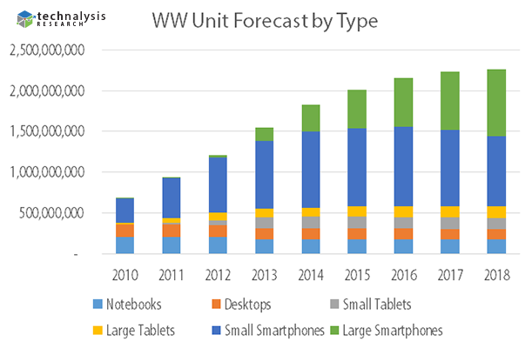
The combined total of the three categories will surpass the 2 billion mark in 2015, but then start to slow and stabilize around 2.25 billion in 2018. As a result of lower prices, particularly for larger smartphones, total device revenues are expected to peak in 2016, which is going to lead to some challenges for companies who have become solely dependent on hardware growth.
“Most tech industry market observers have only been looking at individual device categories over the last several years, so they’ve missed the underlying currents that have been at work across computing devices as a whole,” says TECHnalysis Research founder and chief analyst Bob O’Donnell. “It has never been more clear that the dynamics of one device category have a profound impact on others and only by looking at the big picture of PCs, tablets and smartphones together can you really understand how and why these changes are occurring.”
A copy of the complete report is available for purchase from TECHnalysis Research. For additional information, please e-mail the author at bob@technalysisresearch.com.
Founded by technology market research veteran Bob O’Donnell, TECHnalysis Research, LLC provides strategic consulting and market research services to the technology industry and professional financial community. Building on a deep understanding of critical technology and business trends, in conjunction with hard-hitting, original research, the firm provides unique "out-of-the-box" perspectives that are still grounded in the practical realities of the technology, media and telecom markets.

